**Batch: D2 Roll No.: 16010122323**

**Experiment No. 6**

**Grade: AA / AB / BB / BC / CC / CD /DD**

**Signature of the Staff In-charge with date**

|  |
| --- |
| **Title: Implementation of All Pair Shortest Path using Dynamic Programming** |

**Objective** To learn the All-Pair Shortest Path using Floyd-Warshallalgorithm

**CO to be achieved:**

|  |  |
| --- | --- |
| CO 2 | Describe various algorithm design strategies to solve different problems and analyze  Complexity. |

**Books/ Journals/ Websites referred:**

1. **Ellis horowitz, Sarataj Sahni, S.Rajsekaran,” Fundamentals of computer algorithm”, University Press**
2. **T.H.Cormen ,C.E.Leiserson,R.L.Rivest and C.Stein,” Introduction to algortihtms”,2nd Edition ,MIT press/McGraw Hill,2001**
3. **http://users.cecs.anu.edu.au/~Alistair.Rendell/Teaching/apac_comp3600/module4/all_pairs_shortest_paths.xhtml**
4. **https://www.geeksforgeeks.org/floyd-warshall-algorithm-dp-16/**
5. **http://www.cs.bilkent.edu.tr/~atat/502/AllPairsSP.ppt**

**Theory:**

It aims to figure out the shortest path from each vertex v to every other u.

1. In all pair shortest path, when a weighted graph is represented by its weight matrix W then objective is to find the distance between every pair of nodes.
2. Apply dynamic programming to solve the all-pairs shortest path.
3. In all pair shortest path algorithm, we first decomposed the given problem into sub problems.
4. In this principle of optimally is used for solving the problem.
5. It means any sub path of shortest path is a shortest path between the end nodes.

**Algorithm:**

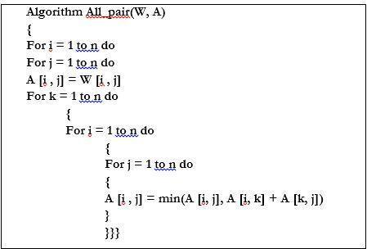

**Example:**

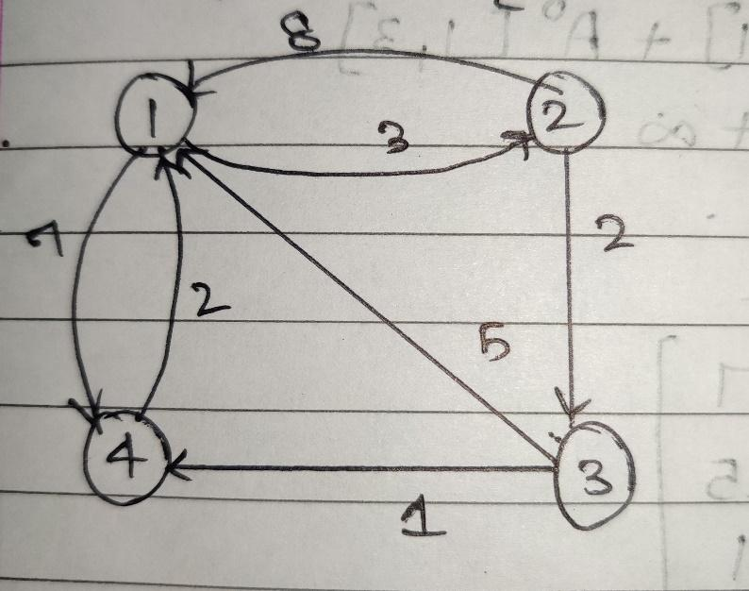

**Solution for the example:**

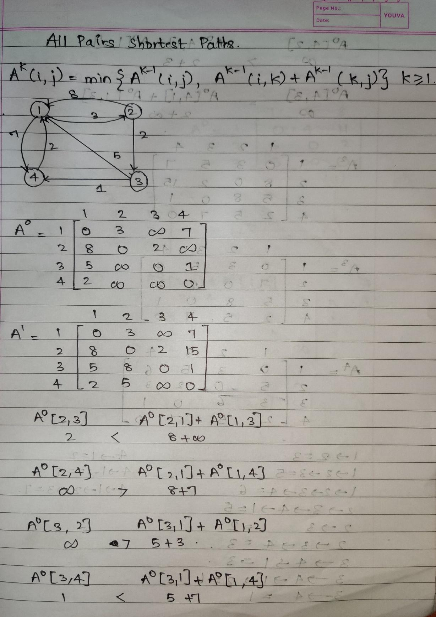

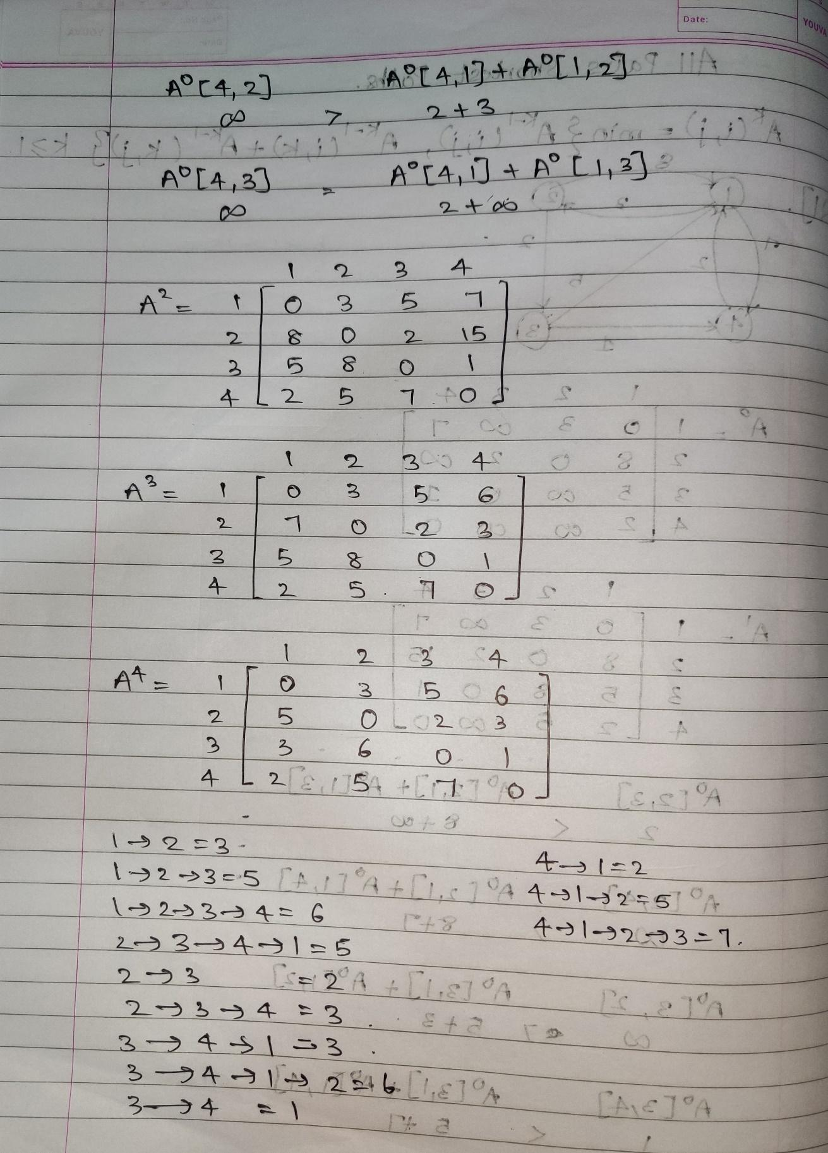**Analysis of algorithm:**

It uses three nested loops. Innermost loop has only one statement. The complexity of that statement is Ɵ(1).

Running time of the algorithm is computed as

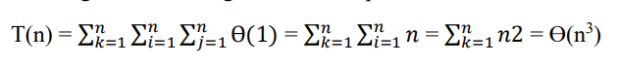

Thus, floyd's algorithm runs in cubic time.

**Code:**

import java.util.*;

import java.lang.*;

import java.io.*;

public class AllPairShortestPath {

    final static int INF = 99999, V = 3;

    void floydWarshall(int graph[][])

    {

        int dist[][] = new int[V][V];

        int i, j, k;

        for (i = 0; i < V; i++)

            for (j = 0; j < V; j++)

                dist[i][j] = graph[i][j];

        for (k = 0; k < V; k++)

        {

            for (i = 0; i < V; i++)

            {

                for (j = 0; j < V; j++)

                {

                    if (dist[i][k] + dist[k][j] < dist[i][j])

                        dist[i][j] = dist[i][k] + dist[k][j];

                }

            }

        }

        printSolution(dist);

    }

    void printSolution(int dist[][])

    {

        System.out.println("The following matrix shows the shortest "+

                         "distances between every pair of vertices");

        for (int i=0; i<V; ++i)

        {

            for (int j=0; j<V; ++j)

            {

                if (dist[i][j]==INF)

                    System.out.print("INF ");

                else

                    System.out.print(dist[i][j]+"   ");

            }

            System.out.println();

        }

    }

    public static void main (String[] args)

    {

        // int graph[][] = { {0,   5,  INF, 10},

        //                   {INF, 0,   3, INF},

        //                   {INF, INF, 0,   1},

        //                   {INF, INF, INF, 0}

        //                 };

        int graph[][]={ {0,4,11},

                        {6,0,2},

                        {3,INF,0}

                    };

        AllPairShortestPath a = new AllPairShortestPath();

        a.floydWarshall(graph);

    }

}

}

Output:

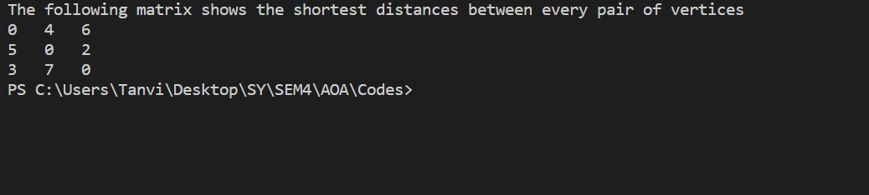

**Conclusion:**

In this experiment, we have learnt Implementation of all Pair Shortest Path using Floyd-Warshall algorithm. We have understood the dynamic programming approach to solve all pairs shortest path problems. We have also understood the algorithm and implemented the same on java. We have compared the time complexity of the program. Additionally, we have understood the applications of single source shortest path problem in real life scenarios.